Write a Custom Event Handler Using the WSO2 Identity Server Eventing Framework

Introduction

WSO2 Identity Server supports the eventing framework, which can be used to trigger some events such as user operations. Also, the eventing framework supports handlers that can be used to do some operations based on the published events.
Ex:
- PRE_AUTHENTICATION
- POST_AUTHENTICATION
- PRE_SET_USER_CLAIMS
- POST_SET_USER_CLAIMS
- PRE_ADD_USER
- POST_ADD_USER
- PRE_UPDATE_CREDENTIAL … etc

To demonstrate this, we are going to print the event properties in the console after a user addition. The following sequence of operations are executed while adding a user.
- Publish the PRE_ADD_USER event
  - The subscribed handlers will be executed for the pre-add user event.
- Execute the AddUser operation.
  - The user will be persisted in the user store (LDAP or JDBC).
- Publish the POST_ADD_USER event
  - The subscribed handlers will be executed for the post-add user event.
Therefore, we can perform our task through an event handler, which is subscribed to the POST_ADD_USER event.

Write an event handler
Follow the steps given below to write the handler.
- To write a new event handler, you must extend org.wso2.carbon.identity.event.handler.AbstractEventHandler.

package org.wso2.carbon.identity.customhandler.handler;

public class UserRegistrationCustomEventHandler extends AbstractEventHandler {

- Override the getName() method to set the name for the event handler and the getPriority() method can be used to set the priority of the event handler.
The handlers will be executed based on priority.

public String getName() {

return "customUserRegistration";
}

public int getPriority(MessageContext messageContext) {

return 250;
}

- The handleEvent() method can be used to do the actual operation. The parameters related to the user operations can be taken from the event.getEventProperties() method.
public void handleEvent(Event event) {

if (IdentityEventConstants.Event.PRE_ADD_USER.equals(event.getEventName())) {

String tenantDomain = (String) event.getEventProperties().get(
IdentityEventConstants.EventProperty.TENANT_DOMAIN);
String username = (String) event.getEventProperties().get(
IdentityEventConstants.EventProperty.USER_NAME);
log.info("Handling the event before adding user: " + username
+ " in tenant domain: " + tenantDomain);
// You can write any code here to handle the event.
}

if (IdentityEventConstants.Event.POST_ADD_USER.equals(event.getEventName())) {

String tenantDomain = (String) event.getEventProperties()
.get(IdentityEventConstants.EventProperty.TENANT_DOMAIN);
String userName = (String) event.getEventProperties().get(
IdentityEventConstants.EventProperty.USER_NAME);
log.info("Handling the event after adding user: " + userName
+ " in tenant domain: " + tenantDomain);
// You can write any code here to handle the event.
}
}

- Register the event handler.
The event handler needs to register in the service component as follows.
package org.wso2.carbon.identity.customhandler.internal;

@Component(
name = "org.wso2.carbon.identity.customhandler.internal
.UserRegistrationCustomEventHandlerComponent",
immediate = true
)
public class UserRegistrationCustomEventHandlerComponent {

private static Log log = LogFactory.getLog(
UserRegistrationCustomEventHandlerComponent.class);

protected void activate(ComponentContext context) {
try {
BundleContext bundleContext = context.getBundleContext();
bundleContext.registerService(AbstractEventHandler.class.getName(),
new UserRegistrationCustomEventHandler(), null);
} catch (Exception e) {
log.error("Error while activating custom User selfRegistration handler”
+ “component.", e);
}
}

Prerequisites
- A WSO2 Identity Server setup.
- Please verify that all the system requirements are satisfied.
- An Application registered in Identity Server.
- An application deployed in Tomcat server.
Ex: pickup-dispatch application
- Enable self Registration in IS
  - In the WSO2 Identity Server Console, from the menu go to Login & Registration > User Onboarding > Self Registration section.
  - Click on the Toggle to Enable.
- Configure the email sending module with WSO2 Identity Server.

Set up

We have implemented a sample custom event handler for you. You can access that from here. Follow the below instructions after cloning the sample-is repo into your local machine.
- Navigate to the event-handler/custom-event-handler directory.
cd event-handler/custom-identity-event-handler

- Run the following command:
mvn clean install

- Copy the generated jar file in the target folder into the <IS_HOME>/repository/components/dropins/ folder.
- To configure the event handler, add the event handler configuration to the <IS_HOME>/repository/conf/deployment.toml file.
The events that need to subscribe to the handler can be listed in subscriptions.
[[event_handler]]
name= "customUserRegistration"
subscriptions = ["PRE_ADD_USER","POST_ADD_USER"]

- Navigate to <IS_HOME>/bin and start the server by issuing one of the following commands based on your operating system:
  - For Linux:
./wso2server.sh

  - For Windows:
./wso2server.bat run

Try it

- Go to http://localhost.com:8080/pickup-dispatch and click Register.
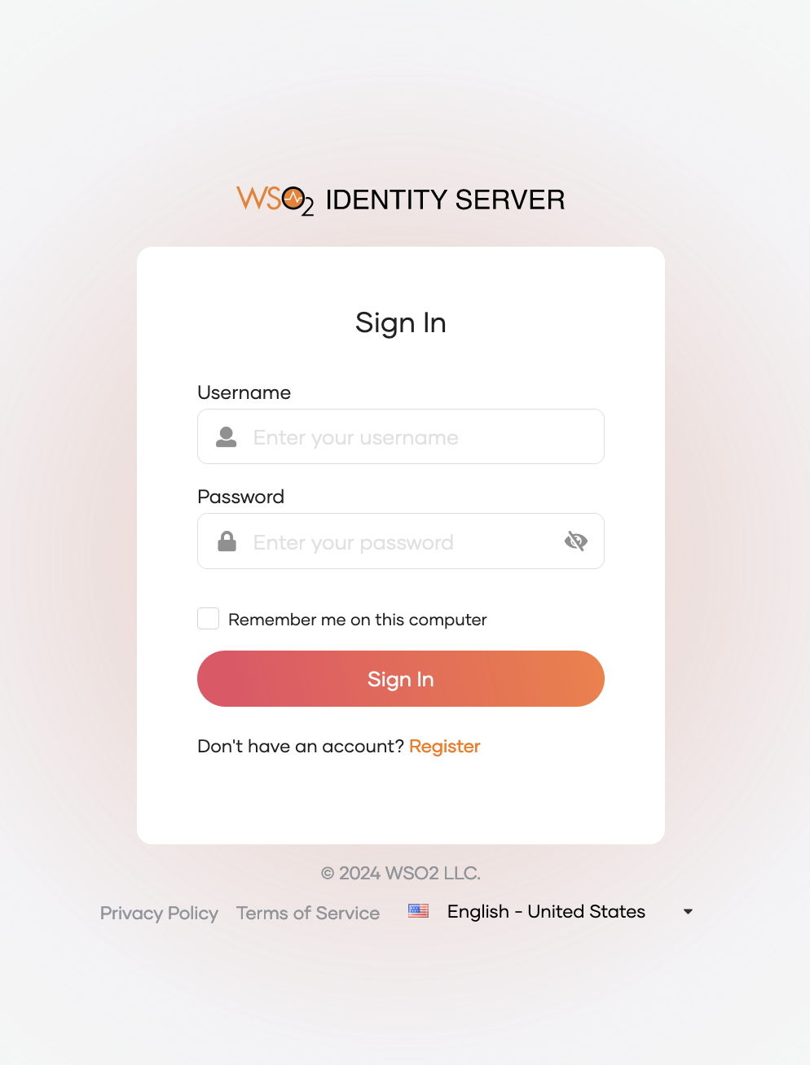

- You will get redirected to the self-registration page of WSO2 Identity Server.
- Add details of the user that need to be onboarded.
- After onboarding the user, check the IS server logs. You should see the logs below.
